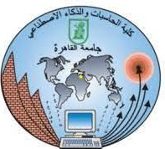

Faculty of computers And Artificial Intelligence

Cairo university

Database Project

Game Rental

|  |  |  |
| --- | --- | --- |
| **Prepared by** | **ID** | **Section** |
| Reham Magdy Mahmoud | 20200191 | S28 |
| Saif ELdeen Mohamad Hassan | 20201096 | S30 |
| Abdelhamid Adel Abdelhamid Mohamed | 20200275 | S33 |
| Mahmoud Wael Ebrahim Mohamed | 20200505 | S30 |
| Shahd Abdallah Ahmed | 20200262 | S27 |
| Esraa Abdelmoneam Mohamed | 20201015 | S19 |